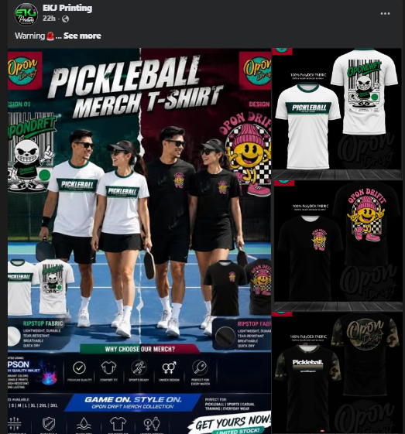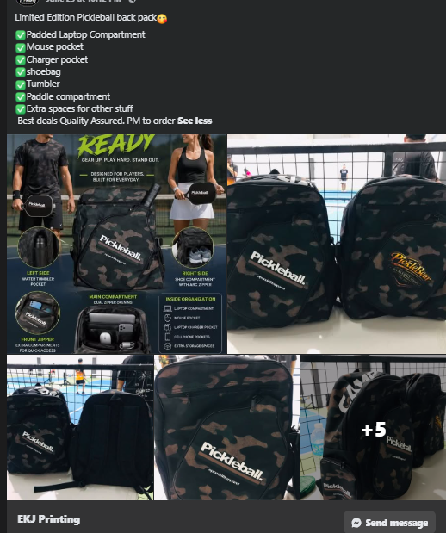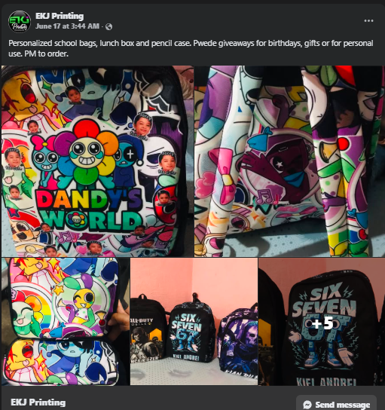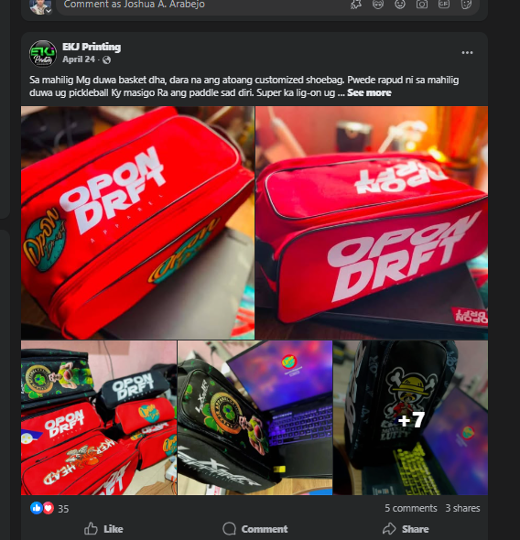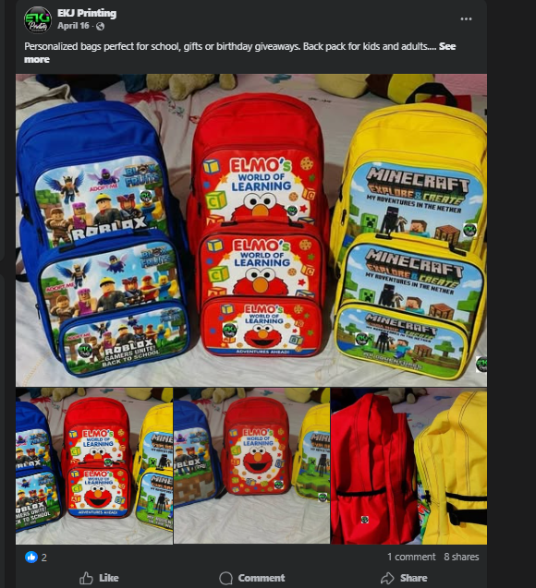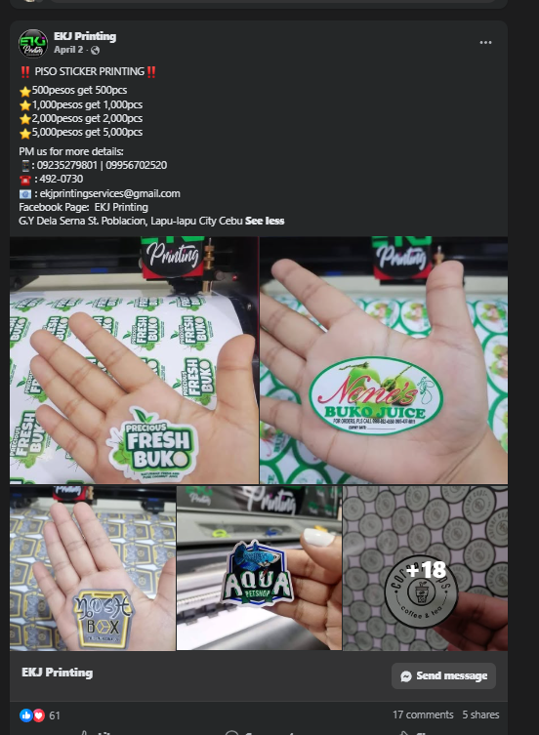

Barato na Sinulog T-shirt
Best seller most pick Sinulog shirt
Full sublimation premium fabric
3rd batch cut off Jan 13 release Jan 16-17.
Message na ky basin mahutdan ka. Dali go na
PRITITIT!!!!!
PINAKA BARATO NGA SINULOG T-SHIRT!!!!
250 pesos only
Full sublimation premium fabric
Pick up or delivery
We ship nationwide
Oder now ky dali rani ma sold out. Mintras available pa order na
